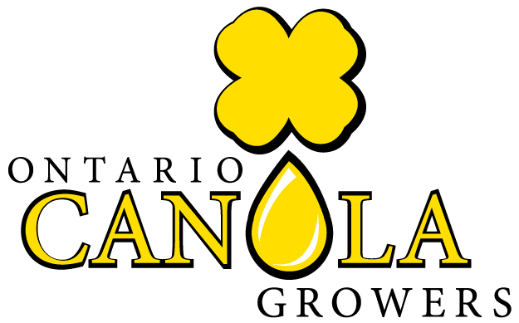

Winter Canola Challenge 2023
Intent to Participate Entry Form
(must be received by June 30, 2023)

Add your information, scan and email to info@ontariocanolagrowers.ca
or
email the information listed below to info@ontariocanolagrowers.ca

Name:

Email:

Phone:

Address:

Phone:

Supporting Agronomist:

Agronomist’s Company:

Agronomist’s Phone or Email Contact Info:

