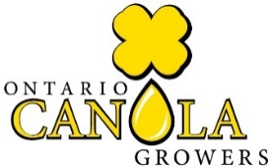
Ontario Spring Canola Challenge 2023— Results Form
Name ____________________________________________________________________
Address (Mailing) ______________________________________________________________
Supporting Agronomist _______________________________________________________
Plot location __________________________________________________________________
Phone ________________________ Email: _______________________________________
YIELD PER ACRE (in lbs): _____________________ Moisture (%)_________
Previous Crop: _______________________ Planting Date: ____________________________
Seed Variety: ________________________________ Seeding rate/acre _________________
Tillage (spring or fall and type of tillage) ____________________________________________
Method of planting: __________________________________________________________
Fertilizer Program:
Manure? How much and when? __________________________________________________
Starter: _____________________________________________________________________
Broadcast (amount per acre and N-P-K-S) _________________________________________
____________________________________________________________________________
In Season Foliar Treatment (for ex AMS, manure, boron) ______________________________
Herbicide applied and when: _____________________________________________________
Insect Pressure, Pesticides Applied and when: ______________________________________
____________________________________________________________________________
Fungicides applied and % bloom: _________________________________________________
Combining method: Swathed or straight cut, type of header_____________________________
Factors that affected your yield ___________________________________________________
____________________________________________________________________________
Grower’s Signature: ______________________________Date: __________________

Agronomist’s Signature: __________________________ Date: __________________
Agronomist’s Company: __________________________

Please complete, email and scan this spring Canola Challenge Results form to:
info@ontariocanolagrowers.ca
Due by October 14, 2022

